BMMK EXAMINATION BOARD

PRIMARY LEAVING MOCK EXAMINATION 2024

23/08/2024

**RE: TERM 3 2024 PROGRAM**

I hereby congratulate all of you for completing a second and hectic term and I thank the Almighty for enabling us reach this far.

I wish to thank you for persisting to the end and for working closely with BMM Educational services

I also wish to give you a program of our proceeding examination sets scheduled as follows:

**PROGRAM FOR TERM 3 2024**

|  |  |  |  |  |
| --- | --- | --- | --- | --- |
| **S/N** | **DATE** | **EXAMINATION** | **COLLECTION** | **MARKING** |
| 1 | 3RD – 4TH OCT 2024 | PRE PLE-SET ONE | 1ST OCT 2024 | 5TH OCT 2024 |
| 2 | 24TH -25TH OCT 2024 | PRE PLE-SET TWO | 22ND OCT 2024 | 26TH OCT 2024 |
| 3 | 14TH – 15TH NOVE 2024 | P.7 ENTRANCE | 12TH NOV 2024 | 16TH NOV 2024 |

You are reminded about the following

1. Make an order for any of the sets above two weeks before time
2. Each candidate will pay shs. 10,000 per set.
3. For those who wish to mark themselves, papers with marking guides shs. 5,000 per set
4. Payment will be done before picking the examination
5. Marking will be done by BMMK Examination Panel.
6. Results will be picked on 8th oct, 29th Oct and 19th Nov 2024 respectively.

I hereby wish to end by thanking all the schools involved in doing BMMK Examinations,

Come again.

I remain,

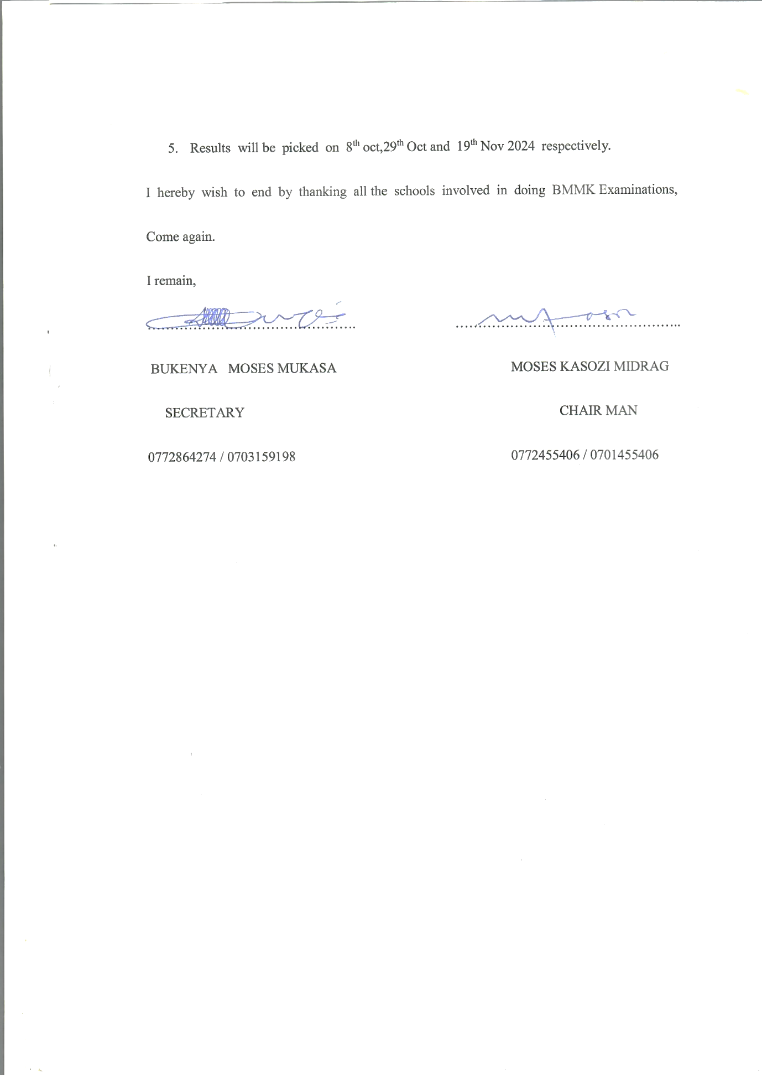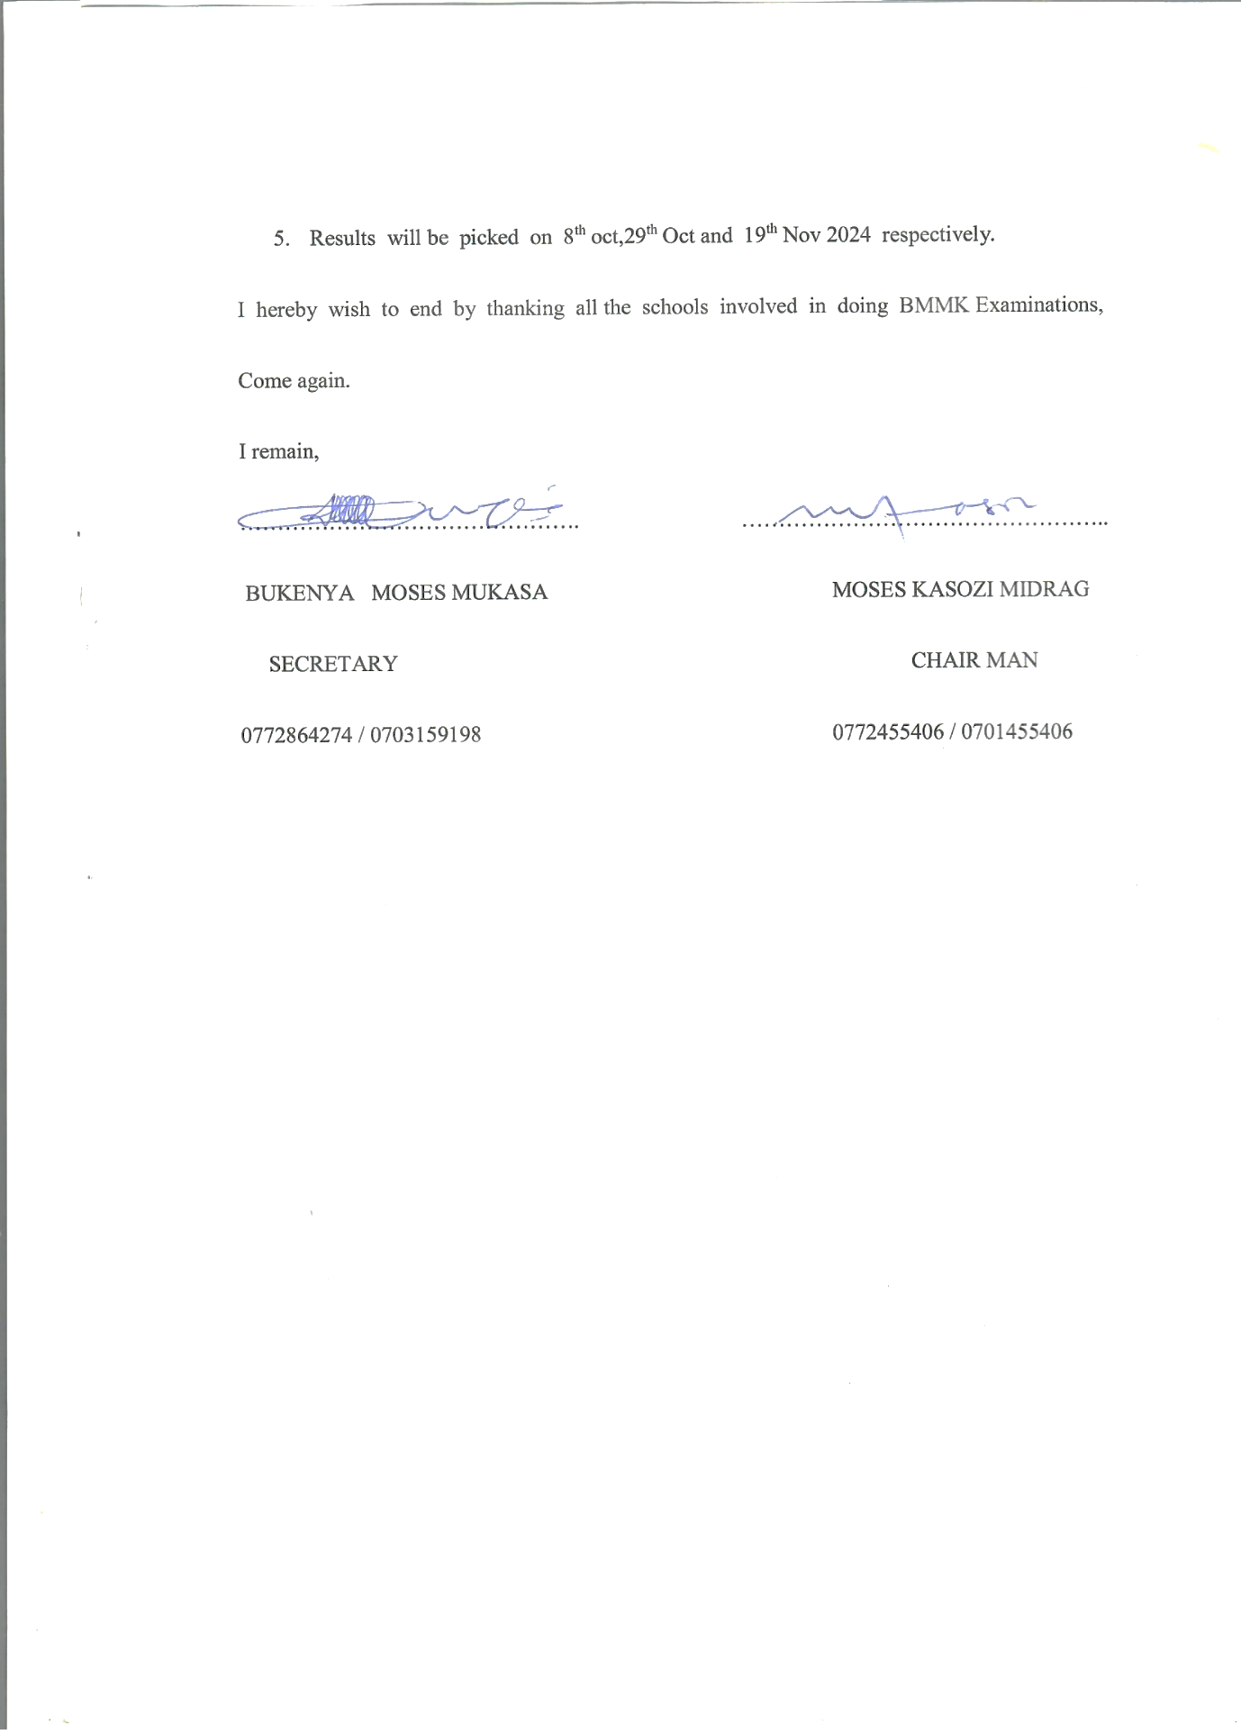

**BUKENYA MOSES MUKASA MOSES KASOZI MIDRAG**

**SECRETARY CHAIRMAN**

**0772864274 / 0703159198 0772455406 / 0701455406**